Multiple-choice section – choose the correct answer

Question 1 [7.1]

‘Three more than twice a number gives a solution of 22’ is:

A 2*n* + 3 = 22 B 3*n* + 2 = 22 C 2(*n* + 3) = 22 D 22 + 3 = 2*n*

Question 2 [7.1]

Use substitution to find the value of *a* in 2*a* − 5 = -11.

A *a* = 3 B *a* = -3 C *a* = 8 D *a* = -8

Question 3 [7.2]

What is the value of *y* where *x* = 2?

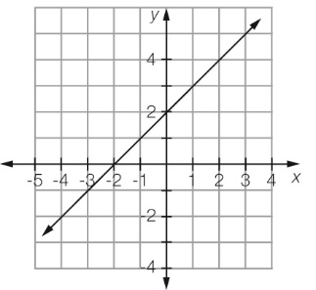

A *y* = 0 B *y* = 3 C *y* = 4 D *y* = 2

Question 4 [7.2]

From the graph in Question 3, what is the value of *x* where *y* = 0?

A *x* = 0 B *x* = -2 C *x* = 2 D *x* = 4

Question 5 [7.2]

To obtain *x* from − 6 you would:

A add 6 and divide by 3 B subtract 6 and divide by 3

C add 6 and multiply by 3 D subtract 6 and divide by 3

Question 6 [7.4]

The solution of the balance diagram is:

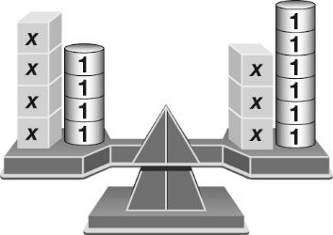

A *x* = 2 B *x* = -2 C 4*x* = 3*x* − 2 D *x* = 3

Question 7 [7.3]

Solve  − 5 = 2.

A *b* = 3 B *b* = 13 C *b* =  D *b* = 28

Question 8 [7.3]

Solve 3(*x* − 6) = 21

A *x* = 1 B *x* = 13 C *x* = 5 D *x* = 9

Question 9 [7.4]

Solve 4*d* − 2 = 2*d* + 10.

A *d* = 2 B *d* = 4 C *d* =  D *d* = 6

Question 10 [7.5]

Isha buys 4 chocolate bars and gets 60 cents change from $5.00. How much was each chocolate bar?

A $1.10 B $1.40 C $1.25 D $1.15

Multiple-choice results: ___ /10

Short answer section

Question 11 3 marks [7.3]

Here is David’s working to solve the equation  – 5 = 7. David has made an error.

David’s working Correct working

 − 5 = 7

 = 12

*x* = 4

(a) Circle the line of working where the error appears.

(b) Write the correct working for the question.

(c) Briefly explain where David went wrong in the calculation.

Question 12 3 marks [7.2]

This graph describes the costs to hire a taxi.

Using specific examples from the graph, write a sentence to describe how a taxi fare is charged.

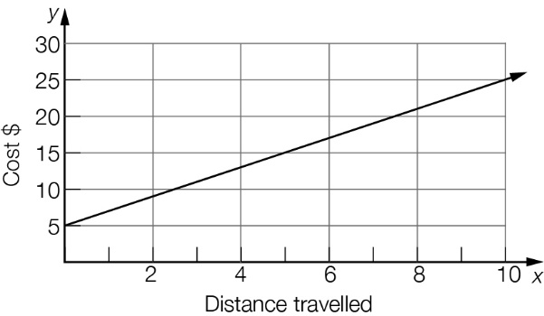

Question 13 2 marks [7.1]

Write an equation for each of the following.

(a) Twice a number (*n*) plus four gives a result of twenty-two.

(b) The sum of a number (*n*) and five is three less than twice the number.

Question 14 4 marks [7.1]

Check by substitution whether the number in the brackets is a solution for the equation.

(a) 3*x* − 5 = 13 (*x* = 6) (b)  = 20 (*x* = 4)

Question 15 2 marks [7.1]

Using words only, write a sentence that fits the equation.

3*m* − 2 = 10

Question 16 2 marks [7.1]

Write an equation for each of these rules, using the given pronumerals for each of the   
quantities described.

(a) Force (*F*) is equal to mass (*M*) multiplied by acceleration (*a*).

(b) The number of red marbles (*R*) in a bag is five less than twice the number of blue marbles (*B*).

Question 17 2 marks [7.2]

Use the diagram to calculate the value of *x*.

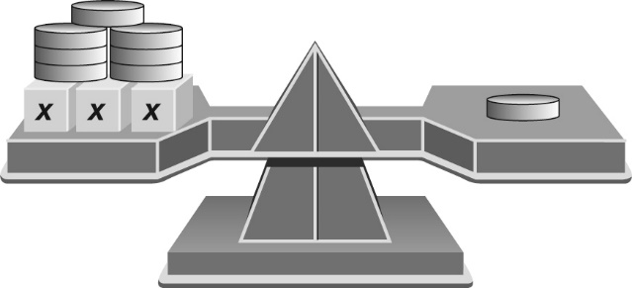

Question 18 4 marks [7.2]

Solve each of these linear equations using algebra.

(a) 3*c* – 5 = 4 (b) 17 + 5*b* = 32

Question 19 4 marks [7.2]

Use the following graph to find the value of:

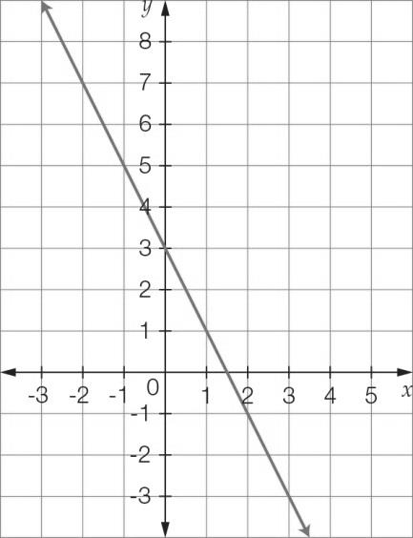

(a) *y* where *x* = 1 (b) *y* where *x* = 2

(c) *x* where *y* = 5 (d) *x* where *y* = 3

Question 20 4 marks [7.2]

Solve each of these linear equations using algebra.

(a) 3*a* − 5 = -17 (b) + 3*x* = 

Question 21 3 marks [7.2]

Jason buys a cup of coffee each week day morning. On two mornings he also buys a sandwich for $4.50. He spends a total of $26.50 for food and drink over the five mornings.

(a) Write an algebraic expression to represent this statement.

(b) What is the cost of a cup of coffee?

Question 22 6 marks [7.3]

Solve the following equations involving fractions.

(a)  = 7 (b)  + 8 = 5

Question 23 6 marks [7.3]

Solve each of the following equations.

(a) 3(*x* − 5) = 21 (b) 4(3*x* + 2) = 44

Question 24 6 marks [7.3]

Write the following statements as equations and then find the value of the unknown.

(a) A number is doubled and then has six subtracted from it. The result is eight. What is the number?

(b) Three is subtracted from a number and the result is tripled. If the total of this is eighteen, what is the number?

Question 25 4 marks [7.2]

A farmer has 420 m of electric fence to fence an area for the horses. The fenced area will be in the shape of a rectangle and be twice as long as it is wide.

(a) Write an equation to represent this information.

(b) Use the equation to find the dimensions of the fenced area.

Question 26 3 marks [7.4]

Use the diagram to calculate the value of *x*.

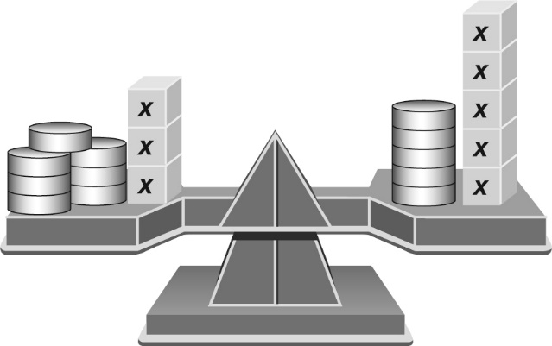

Question 27 6 marks [7.4]

Solve the following equations using algebra.

(a) 5*x* − 4 = 2*x* + 5 (b) 3*x* + 4 = 8*x* − 11

Question 28 6 marks [7.4]

Solve the following equations using algebra.

(a) 3*x* − 6 = 2(*x* + 5) (b) 6(*x* + 2) = 2(1 − 2*x*)

Question 29 6 marks [7.4]

Solve the following equations using algebra.

(a)  =  (b) = 

Question 30 6 marks [7.4]

Solve the following equations graphically by finding the point of intersection of relevant graphs.

(a) 2 − *x* = *x*

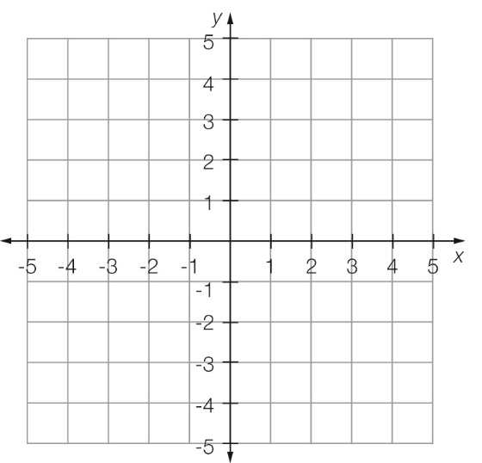

(b) 3*x* + 5 = 1 − *x*

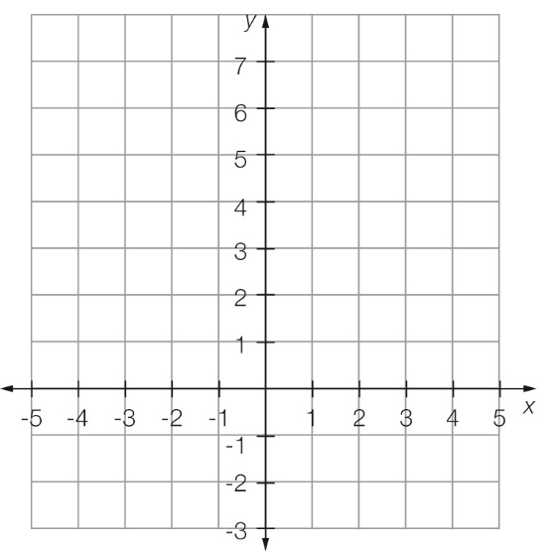

Short answer results: ___ / 82

Extended answer section

Question 31 5 marks [7.2, 7.5]

Peta has a mobile phone plan that provides $350 of SMS and calls each month. Each month it costs $35 plus the cost of any additional SMS and calls over the $350 covered by the plan.

SMS cost 22 cents each and calls cost $0.50 plus 12 cents per 10 seconds.

(a) Write an equation for the cost of a call $*C* that is *n* minutes long. (Note that she is charged by the 10-second interval.)

(b) What is the cost of a call that is 11 minutes long?

(c) What is the cost of 5 calls with a total time of 50 minutes?

(d) One month Peta has calls with a total cost of $213 and sends a total of 793 texts. What is her bill for this month?

Question 32 10 marks [7.3, 7.5]

A pool is four times as long as it is wide. The pool is enclosed by a fence, which is 3 m from each side of the pool, as shown in the diagram. The width of the pool is *w* metres.

(a) Clearly label the measurements in terms of *w* on the diagram below.

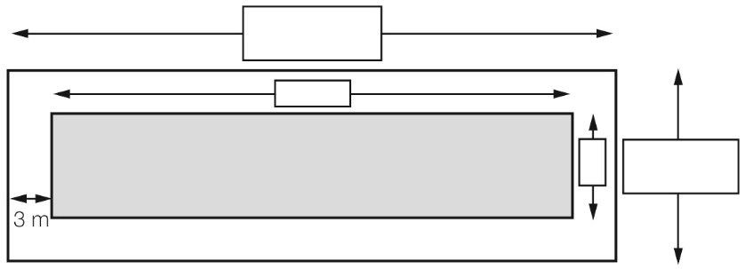

(b) Write an equation for the perimeter (*P*) of the fence.

(c) If the pool can be fenced with 174 m of fencing, what are the dimensions of the pool?

(d) Entry to the pool is $2.00 for children and $4.00 for adults. On a particular day 420 people attend the pool. There are twice as many children as adults.

(i) Write an expression for the number of adults at the pool and hence calculate the number of adults at the pool.

(ii) Calculate the total amount of money collected in entry fees.

Extended answer results: ___ / 15

TOTAL test results: ___ / 107